Chase Gibson

Twilio Submission

Executive Summary

***Situation***: *Question posed regarding the effect of vaccinations on COVID mortality in Cincinnati prior to the anticipated impact of the Omicron variant.*

***Analysis***: I pulled daily data from the Ohio department of health for mortality and vaccinations. Data date ranges:

* + - Mortality: March 2020-present
    - Vaccination: December 2020-present

My data shows 140k cases with ~1700 deaths (roughly 1% mortality rate). For cases resulting in hospitalizations, 33% result in mortality.

. 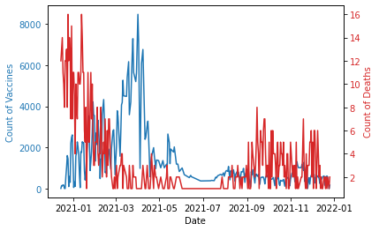

I investigated to find the correlation between vaccination and mortality rates to confirm that vaccinations have a negative effect on mortality rates. The data shows a moderate correlation between these elements. Modeling the data for forecasting suggests that vaccination rates remain stable even as cases trend higher. If there is an expected increase in cases due to the Omicron variant, we would expect to see increased morality in the absence of increased vaccinations.

***Recommendation***: We should do whatever possible to incentivize increased vaccinations if we want to lower mortality risk.

***Potential Next steps*:**

* Generalize model and expand analysis to include additional geographies to confirm findings
* Further enhance the model to create predictions for low/medium/high case expansions
* Share findings with extended organization